**SUPPLEMENTARY FIGURES FOR MANUSCRIPT**

**Title: Causal relationships between gut microbiome and age-related traits**

**Authors**

Federica Grosso1, Daniela Zanetti1, Serena Sanna1

**Affiliations**

1Institute for Genetic and Biomedical Research (IRGB) of the National Research Council (CNR), Monserrato (CA), Italy

**Supplementary Figure 1. Workflow of the study**

This workflow shows all the steps of the MR analysis examining the causal link between the gut microbiome and specific age-related outcomes.

(IV: instrumental variable, GWAS: genome-wide association study, MR: Mendelian randomization, NAs: missing values, SNP: single nucleotide polymorphism, QC: quality control)

**Supplementary Figure 2. Scatter plot of main MR analysis between Coriobacteriales and age-related macular degeneration.**

This figure shows the results of the main MR analysis between Coriobacteriales (o__Coriobacteriales or f__Coriobacteriaceae) and AMD. In the scatter plot, each dot is an IV and the x and y-axis represents the association coefficients with the exposure and outcome, respectively. The three lines represent the results of the three different MR tests, with the slope of the lines being equal to causal estimates of each test.

(AMD: age-related macular degeneration, IV: instrumental variable, MR: Mendelian randomization, SNP: single nucleotide polymorphism).

**Supplementary Figure 3**. **Leave-one-out plot main MR analysis between *Coriobacteriales* and age-related macular degeneration.**

In this figure the causal estimates from the leave-one-out analyses between *Coriobacteriales* (*o__Coriobacteriales* or *f__Coriobacteriaceae*) and AMD are shown and compared with the causal estimate from main analysis (red line).

(AMD: age-related macular degeneration, MR: Mendelian randomization)

**Supplementary Figure 4. Replication analyses between *Coriobacteriales* vs independent GWASs of age-related macular degeneration**

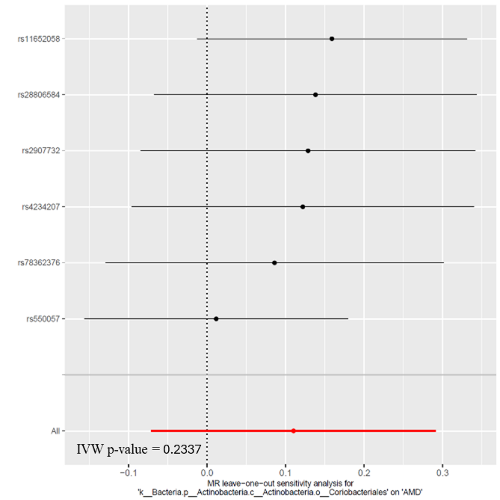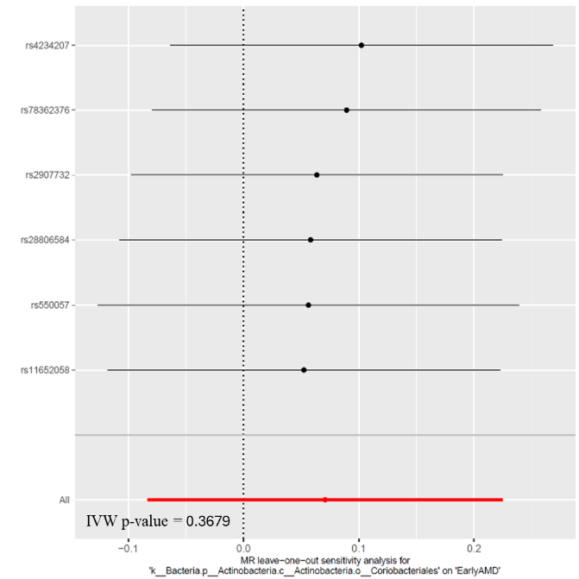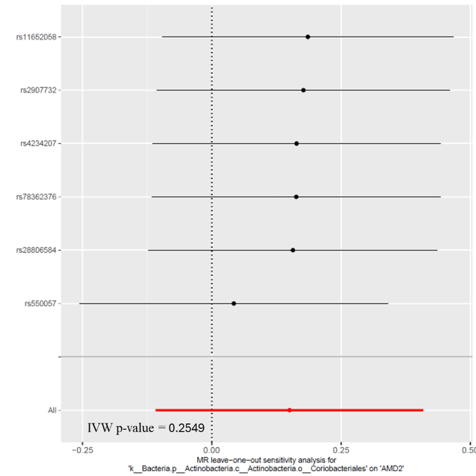

**a)**

**b)**

**c)**

The **panel a)** shows the leave-one-out plot of MR replication with GWAS of age-related macular degeneration (AMD2) from Guindo-Martinez et al., 2021 (GCST90086112) and the exposure *Coriobacteriales* (*o__Coriobacteriales* or *f__Coriobacteriaceae*). The **panel b)** shows the leave-one-out plot of MR replication analysis with “Early AMD” GWAS from Winkler et al., 2020 (GCST010723) as outcome. The **panel c)** represents leave-one-out plot of replication analysis with AMD GWAS from FinnGen study (<https://www.finngen.fi/en/access_results>) as outcome.

(AMD: age-related macular degeneration, GWAS: genome-wide association study, IVW: inverse variance weighted, MR: Mendelian randomization)

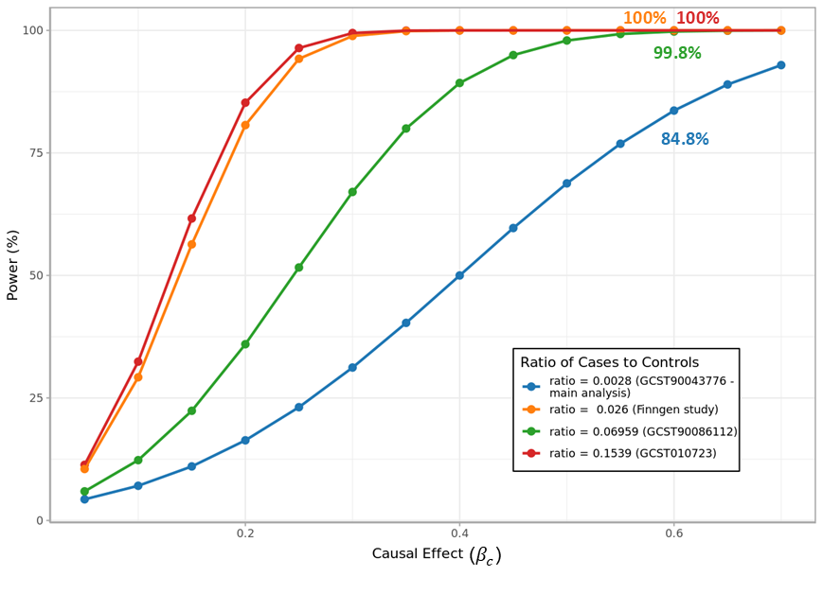

**Supplementary Figure 5. Power estimates of *Coriobacteriales* vs age-related macular degeneration analysis**

This plot shows the power estimates at varying causal effect sizes , for independent studies of age-related macular degeneration as outcome. The causal effect identified in the main analysis () and corresponding power are highlighted in the curves.

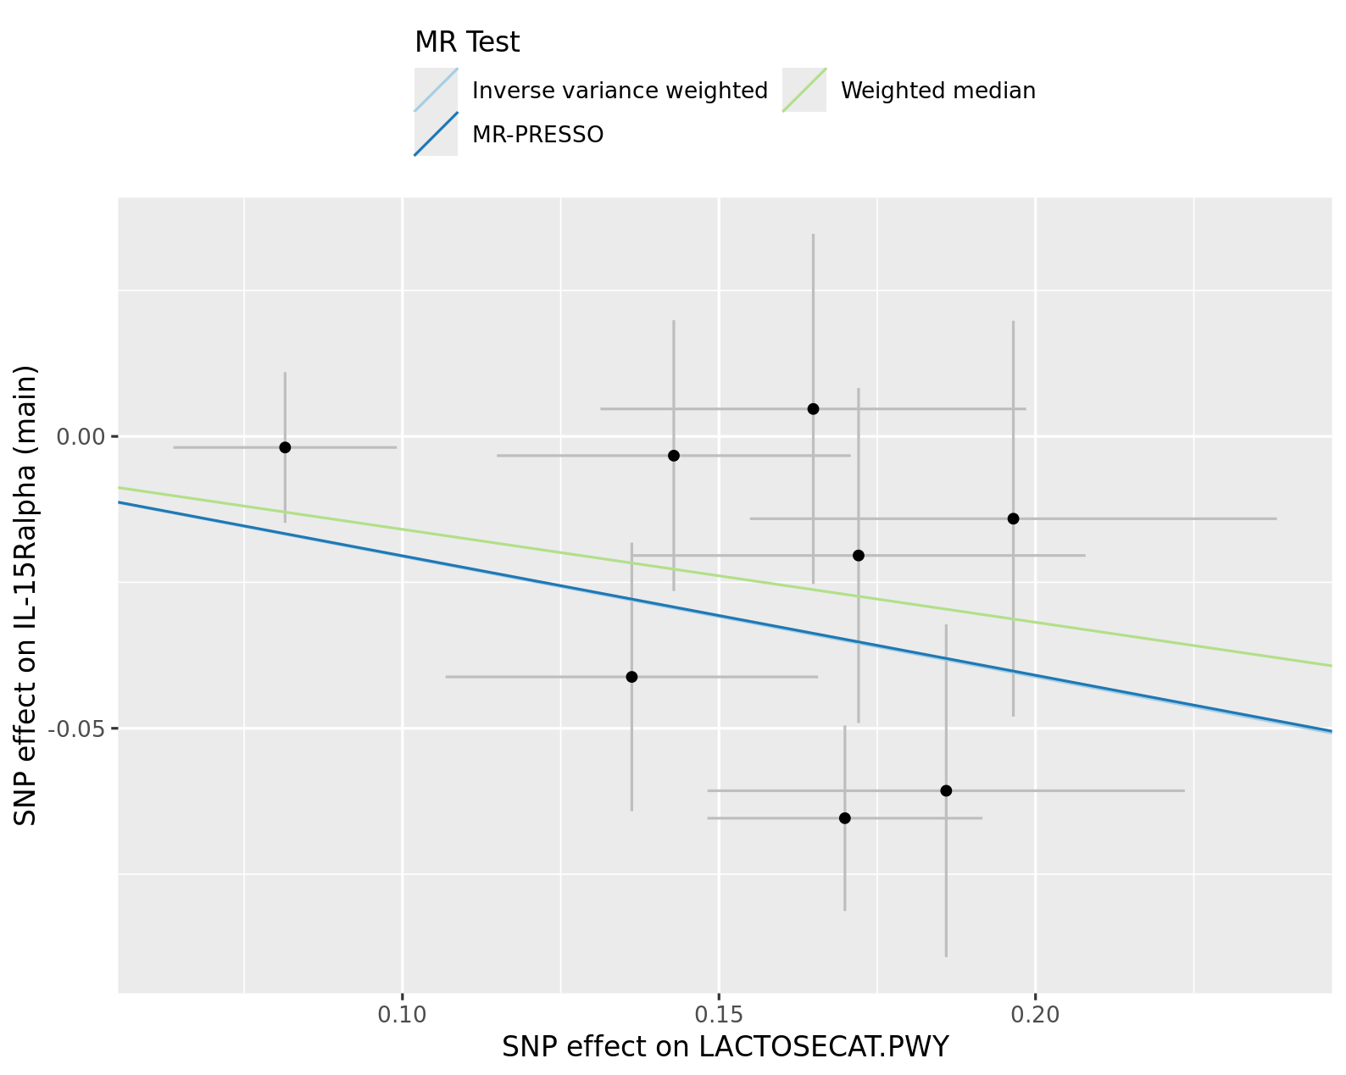

**Supplementary Figure 6. Scatter plot of MR analysis between LACTOSECAT.PWY and IL-15R protein levels.**

This figure shows the results of the main MR analysis between LACTOSECAT pathway and IL-15R protein levels. In the scatter plot, each dot is an IV and the x and y-axis represents the association coefficients with the exposure and outcome, respectively. The three lines represent the results of the three different MR tests, with the slope of the lines being equal to causal estimates of each test.

(IL-15R: Interleukin-15 receptor subunit alpha, LACTOSECAT PWY: lactose and galactose degradation I pathway, IV: instrumental variable, MR: Mendelian randomization, SNP: single nucleotide polymorphism)

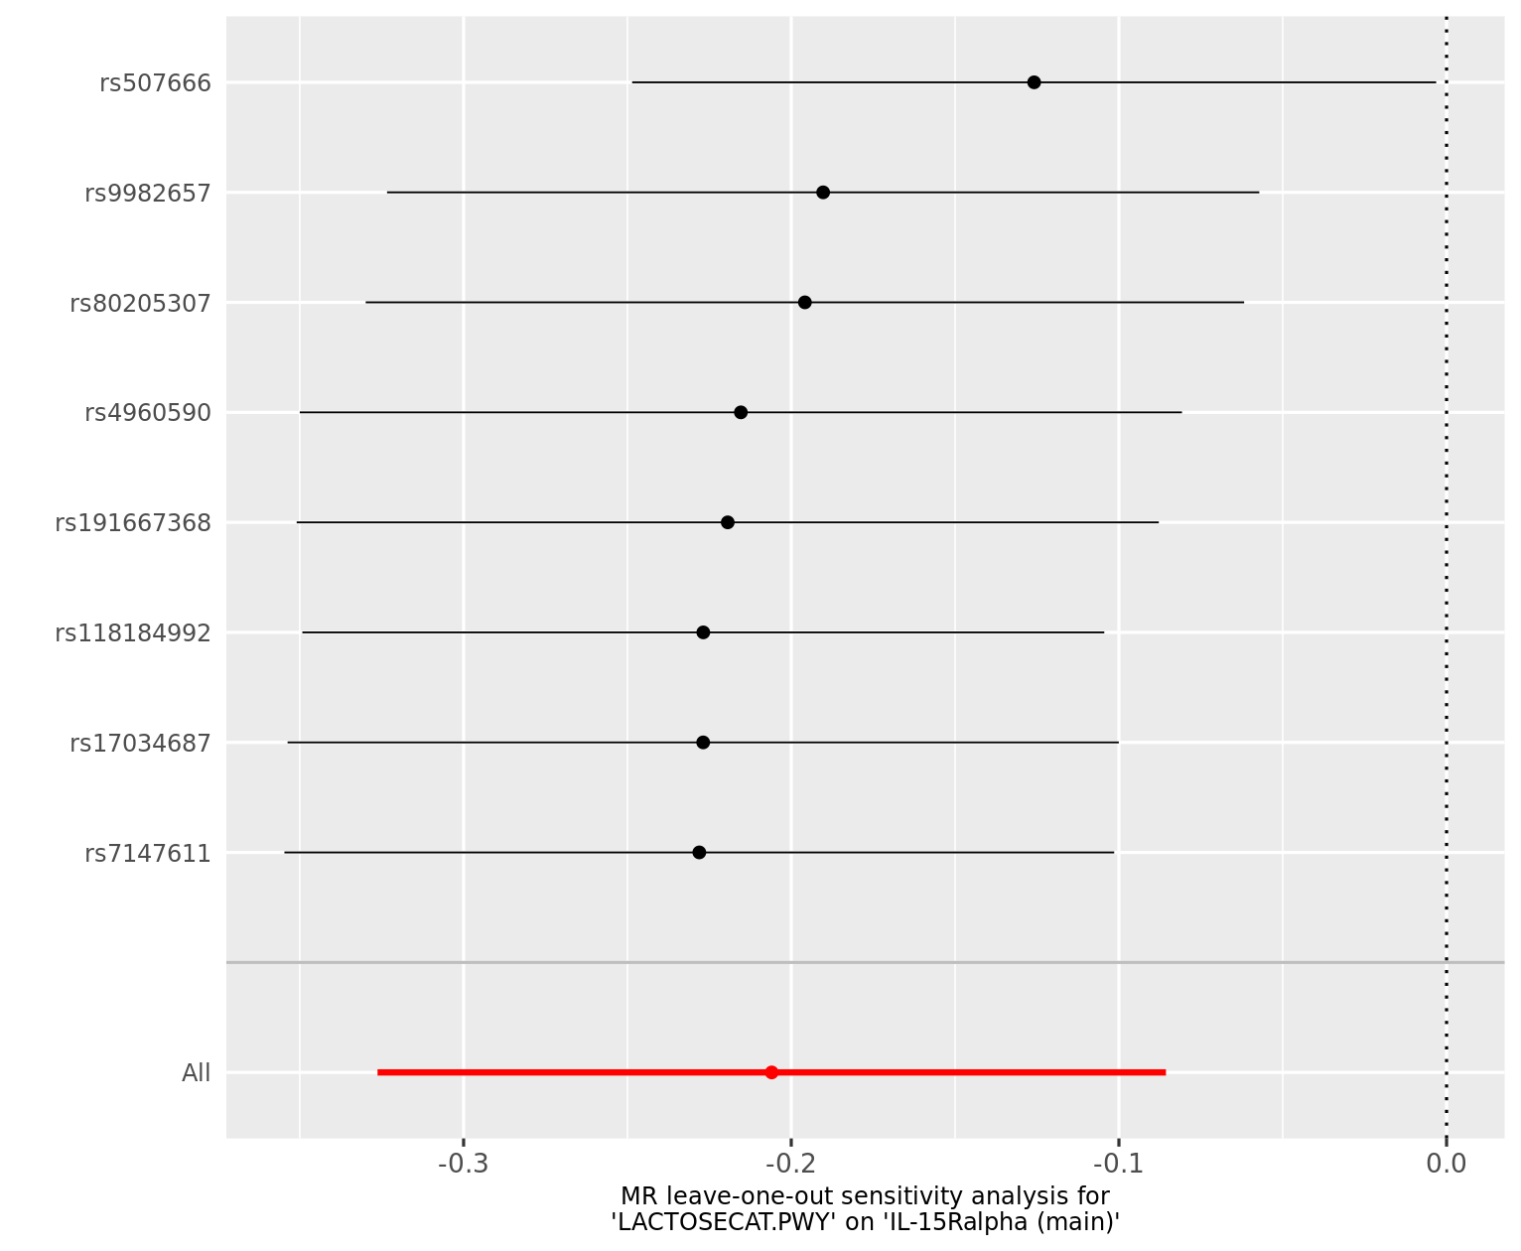**Supplementary Figure 7. Leave-one-out plot main MR analysis between LACTOSECAT pathway and IL-15R protein levels*.***

In this figure the causal estimates from the leave-one-out analyses between LACTOSECAT pathway and IL-15R protein levels are shown and compared with the causal estimate from main analysis (red line).

(IL-15R: Interleukin-15 receptor subunit alpha, LACTOSECAT PWY: lactose and galactose degradation I pathway, MR: Mendelian randomization)

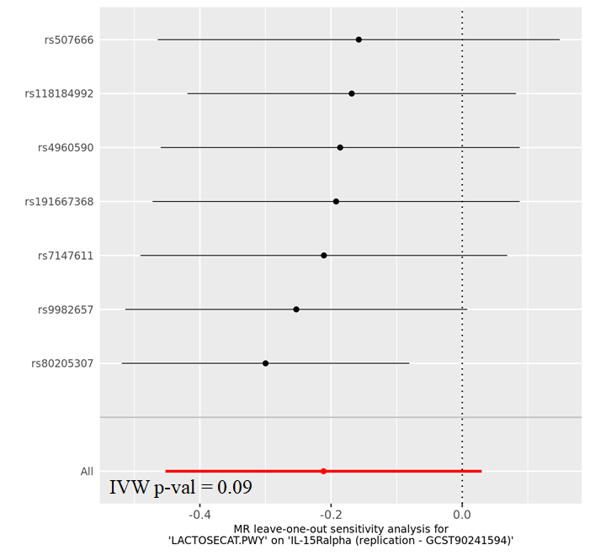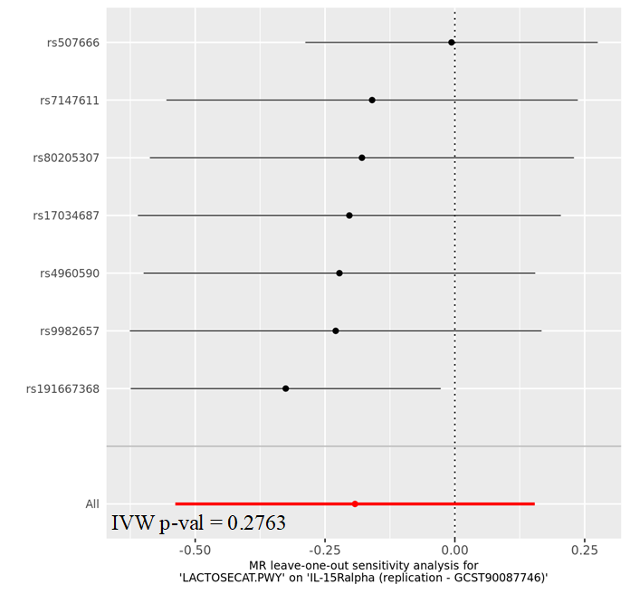

1. **b)**

**Supplementary Figure 8. Replication analyses between LACTOSECAT pathway vs independent GWASs of IL-15R**.

The **panel a)** shows the leave-one-out plot of replication with GWAS of IL-15R from Gudjonsson et al., 2022 (GCST90241594) and the exposure LACTOSECAT.PWY used in the main analysis. The **panel b)** shows the replication of MR analysis using the IL-15R GWAS from Folkersen et al., 2020 (GCST90087746) as outcome.

(GWAS: genome-wide association study, IL-15R: Interleukin-15 receptor subunit alpha, IVW: inverse variance weighted, LACTOSECAT PWY: lactose and galactose degradation I pathway, MR: Mendelian randomization)

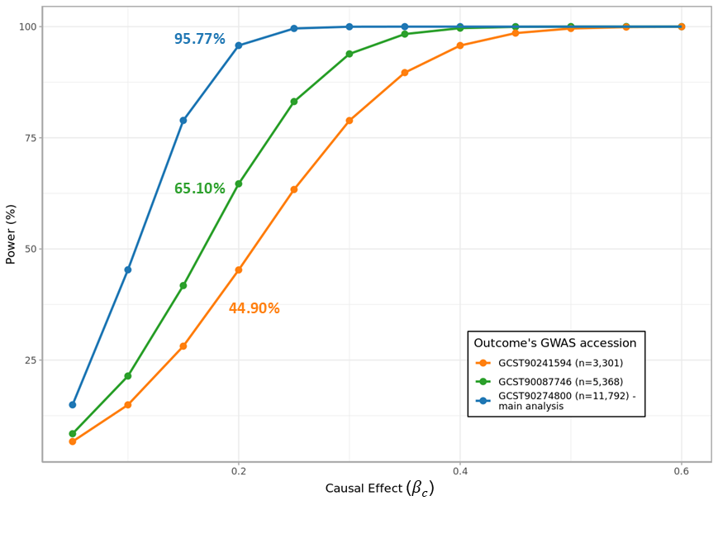

**Supplementary Figure 9. Power estimates of the analysis between LACTOSECAT pathway vs IL-15R**

Power estimates at varying causal effect sizes *,* for independent studies of IL-15R as outcomes. The causal effect identified in the main analysis () and corresponding power are highlighted in the curves.

(IL-15R: Interleukin-15 receptor subunit alpha levels, LACTOSECAT PWY: lactose and galactose degradation I pathway)

**Supplementary Figure 10. Scatter plot of MR analysis between *Bifidobacterium adolescentis* and TNFSF12 protein levels.**

This figure shows the results of the main MR analysis between *Bifidobacterium adolescentis* and TNFSF12 protein levels. In the scatter plot, each dot is an IV and the x and y-axis represents the association coefficients with the exposure and outcome, respectively. The three lines represent the results of the three different MR tests, with the slope of the lines being equal to causal estimates of each test.

(IV: instrumental variable, MR: Mendelian randomization, SNP: single nucleotide polymorphism, TNFSF12: tumor necrosis factor ligand superfamily member 12)

**Supplementary Figure 11. Leave-one-out plot main MR analysis between *Bifidobacterium adolescentis* and TNFSF12 protein levels.**

In this figure the causal estimates from the leave-one-out analyses between *Bifidobacterium adolescentis* and TNFSF12 protein levels are shown and compared with the causal estimate from main analysis (red line).

(MR: Mendelian randomization, TNFSF12: tumor necrosis factor ligand superfamily member 12)

**b)**

**a)**

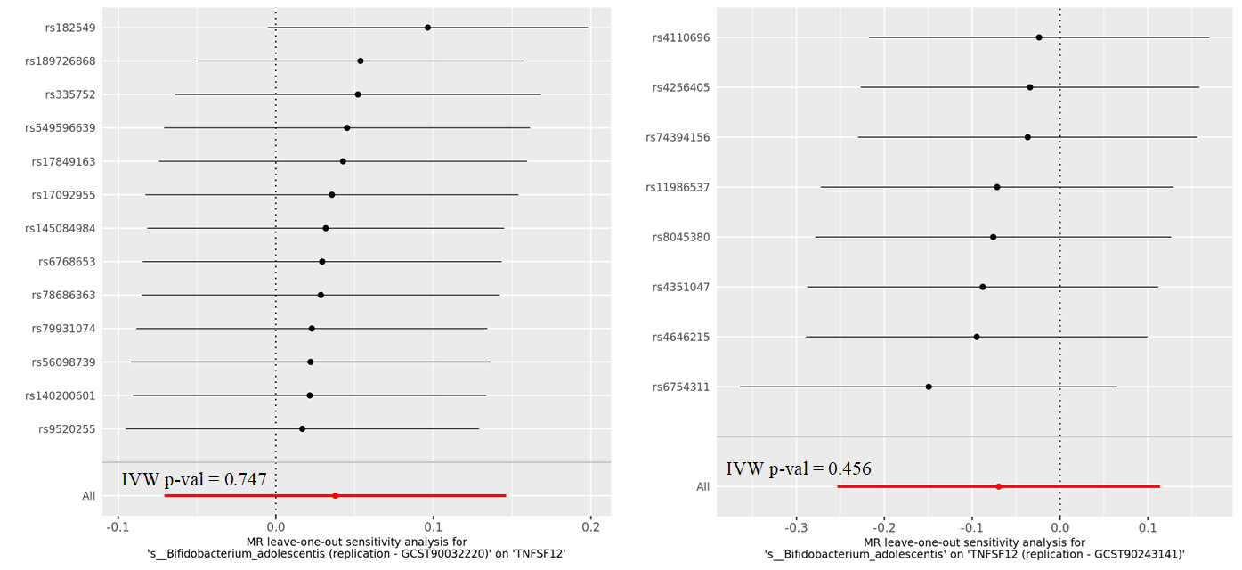

**Supplementary Figure 12. Leave-one-out results of replication analyses between *Bifidobacterium adolescentis vs* TNFSF12 protein levels.**

The **panel a)** shows the leave-one-out plot of replication analysis with *Bifidobacterium adolescentis* GWAS from Qin et al., 2022 (GCST90032220) vs TNFSF12 protein levels from Zhao et al., 2023 (GCST90274846), the one used in main analysis. The **panel b)** shows the leave-one-out plot of replication analysis with *Bifidobacterium adolescentis* of the main analysis (GCST90027754) vs TNFSF12 protein levels from Sun et al., 2023 (GCST90243141) as outcome.

(GWAS: genome-wide association study, IVW: inverse variance weighted, MR: Mendelian randomization, TNFSF12: tumor necrosis factor ligand superfamily member 12)

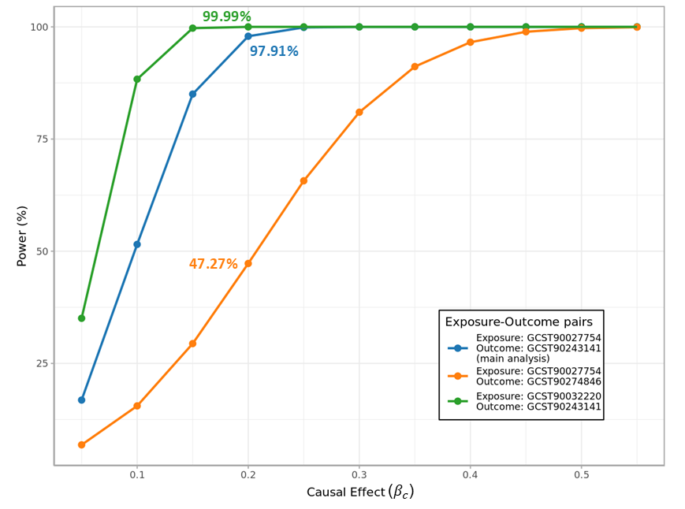**Supplementary Figure 13. Power estimates of the analysis between *Bifidobacterium adolescentis vs* TNFSF12 protein levels.**

Power estimates at varying causal effect sizes of replication analyses with *Bifidobacterium adolescentis* as exposure and TNFSF12 protein as outcome in independent GWAS studies for different exposure-outcome pairs. The causal effect identified in the main analysis () and corresponding power are highlighted in the curves.

(GWAS: genome-wide association study, TNFSF12: tumor necrosis factor ligand superfamily member 12)